**SMART FARMER – IoT ENABLED SMART FARMER APPLICATION**

**ASSIGNMENT – 4**

|  |  |
| --- | --- |
| **Team ID** | PNT2022TMID12911 |
| **Name** | SONA. S |
| **Roll No.** | 718019L252 |

1. **Write Code and connections in wokwi for ultrasonic sensor. Whenever distance is less than 100 centimetres send an *‘alert’* to the ibm cloud and display in device recent events.**

**Program:**

#define ECHO_PIN 2

#define TRIG_PIN 3

void setup() {

**Serial**.begin(115200);

  pinMode(LED_BUILTIN, OUTPUT);

  pinMode(TRIG_PIN, OUTPUT);

  pinMode(ECHO_PIN, INPUT);

}

float readDistanceCM() {

  digitalWrite(TRIG_PIN, LOW);

  delayMicroseconds(2);

  digitalWrite(TRIG_PIN, HIGH);

  delayMicroseconds(10);

  digitalWrite(TRIG_PIN, LOW);

  int duration = pulseIn(ECHO_PIN, HIGH);

  return duration * 0.034 / 2;

}

void loop() {

  float distance = readDistanceCM();

  if(distance<100)

  {

**Serial**.println("Alert!!!!!!!!!");

  }

**Serial**.print("Measured distance: ");

**Serial**.println(readDistanceCM());

  delay(100);

}

**Wokwi Editor window:**

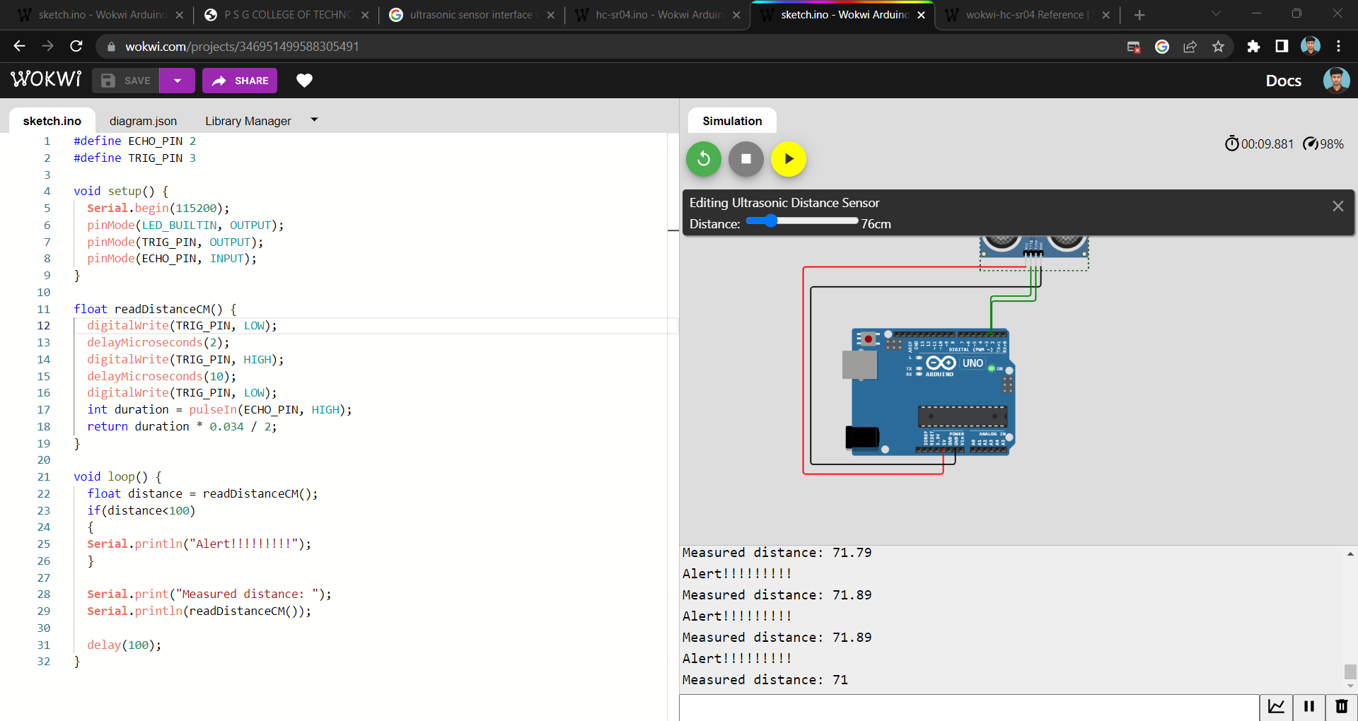

**Results:**

1. The measured distance is less than 100 centimetres, it gives alert message

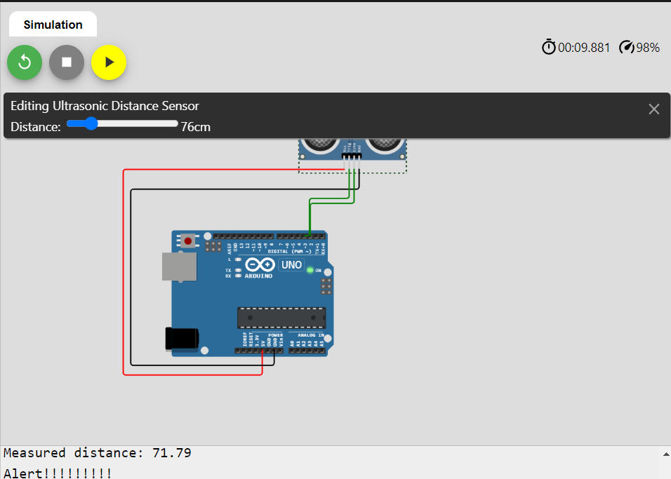

1. The measured distance is more than 100 centimetres, it will not give alert message

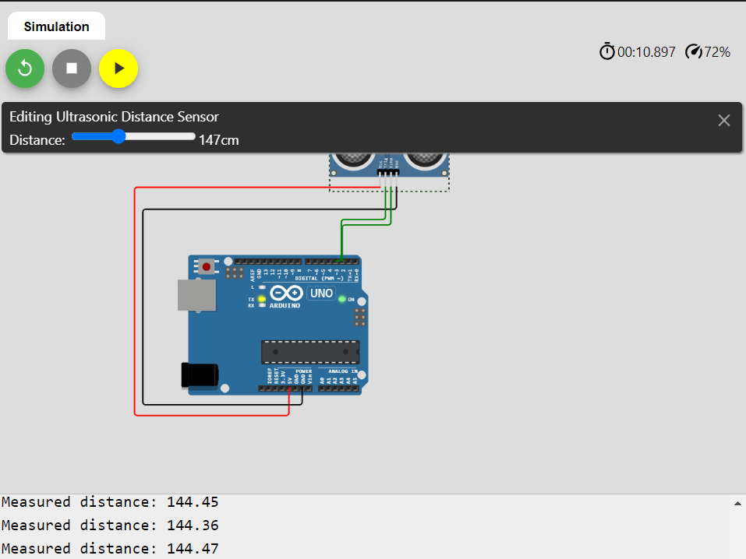

**Wokwi Link:**

[**https://wokwi.com/projects/346951499588305491**](https://wokwi.com/projects/346951499588305491)